|  |  |
| --- | --- |
| Project Name |  |
| Project Number |  |
| Date / Version | 6 September 2018, version DRAFT |
| Analyst |  |
| Project Owner |  |
| Sponsoring Entity |  |

Description of Requested Project

This project implements an updated design for the multi-step transactional forms presented on the website and the mobile app.

Contents

**1 Project Information 3**

1.1 Stakeholders 3

1.2 Project Affects These Applications 3

**2 Auction Registration Form 4**

2.1 Auction Registration Step 1 - Terms & Conditions 4

2.2 Auction Registration Step 2 - Contact Information 5

2.2.1 Use existing phone number 5

2.2.2 Enter new phone number 6

2.3 Auction Registration Step 3 – Thank you! 7

2.4 Auction Registration Mobile App 8

**3 Online Offer Form 10**

3.1 Online Offer Step 1 - Make Your Offer 10

3.2 Online Offer Step 2 - Contact Information 11

3.2.1 Use existing phone number 11

3.2.2 Enter new phone number 12

3.3 Online Offer Step 3 - Agent Information 13

3.4 Online Offer Step 4 - Terms & Conditions 15

3.5 Online Offer Step 5 - Thank you! 16

3.6 Online Offer Mobile App 17

Project Information

# Project Information

## Stakeholders

|  |  |  |
| --- | --- | --- |
| Manager | Department/LOB | Approval Requirement |
| Name | Department | Required |
| Name | Department | Acknowledgement |
|  |  |  |

## Project Affects These Applications

|  |  |
| --- | --- |
| Application | Affected |
| SalesForce |  |
| SL Auction Integration Layer |  |
| WordPress |  |
| SL Auction UI | X |
| iOS Mobile App | X |
| Android Mobile App |  |

Requirements

# Auction Registration Form

## Auction Registration Step 1 - Terms & Conditions

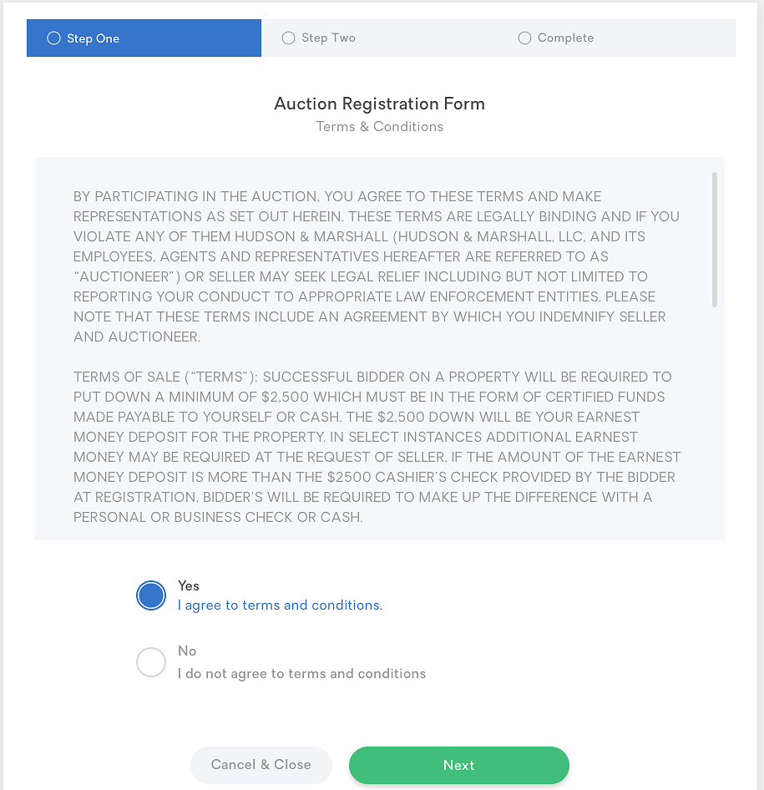

* Highlight Step 1 in the progress tracker and display the Terms & Conditions in a scrollable region.
* Display options to accept [or reject] the T&C; neither option should be pre-selected.
* Enable the Next button only after the user selects the “I agree” option.

## Auction Registration Step 2 - Contact Information

### Use existing phone number

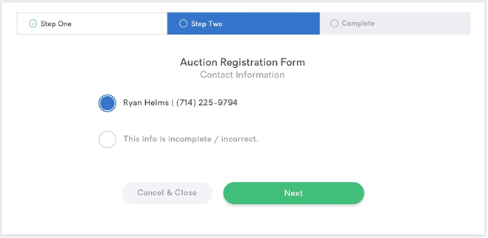

* Update the progress tracker; highlight Step 2.
* Prompt the user to confirm or correct contact details.
* All user profiles will include a first and last name. (Currently, users who create their account via the mobile app will not have a phone number. A future enhancement will require all users to enter a phone number when creating an account for ServiceLink Auction).
* When the user’s profile includes a phone number:
  + Pre-select the option showing the name and phone number.
  + Enable the option to complete/correct the contact information displayed (i.e., allow the user to change this information; if this option is selected, see screen on the next page).
  + Enable the Next button (i.e., allow the user to accept the current values and continue to the next step).
* When the user’s profile does not include a phone number:
  + Disable the option showing the user’s name (the user cannot select the existing values when phone number is missing).
  + Pre-select the option to complete/correct the contact information so the phone number can be entered.
  + *See screen on the next page.*

### Enter new phone number

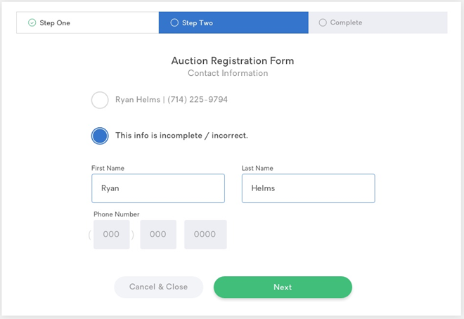

* If contact information is to be completed or corrected:
  + Display data entry form with editable fields for name and phone number.
  + Pre-fill the first and last name fields with the name from the user’s profile.
  + Pre-fill the phone number field if a value exists in the user’s profile.
* All fields are required.
* Disable the Next button until after the user completes the form fields or selects the option to use existing contact information.

## Auction Registration Step 3 – Thank you!

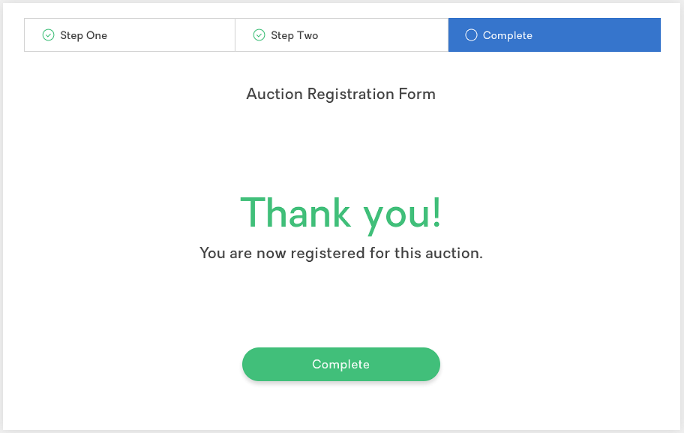

* Update the progress tracker; highlight Step 3.
* Prompt the user to close the form and return to the auction site/app.

## Auction Registration Mobile App

The Auction Registration process on the mobile app should be the same multi-step process used on the website.

|  |  |
| --- | --- |
|  |  |

|  |  |
| --- | --- |
|  |  |

# Online Offer Form

## Online Offer Step 1 - Make Your Offer

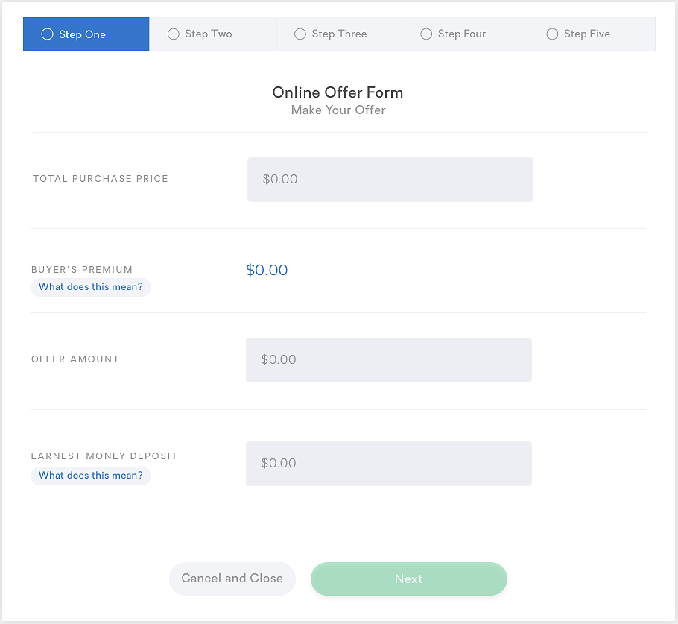

* Highlight Step 1 in the progress tracker and display the offer entry form.
* All fields are required.
* Offer Amount is derived once the user enters the Total Purchase Price:
  + Rule1
  + Rule2
  + Rule3
* Enable the Next button only after the user completes all fields with no errors.

## Online Offer Step 2 - Contact Information

### Use existing phone number

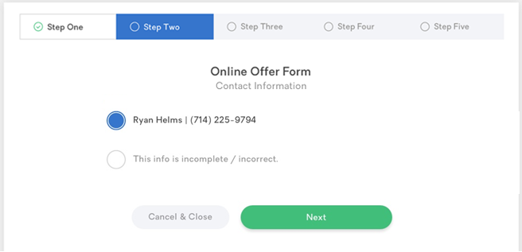

* Update the progress tracker; highlight Step 2.
* Prompt the user to confirm or correct contact details.
* All user profiles will include a first and last name. (Currently, users who create their account via the mobile app will not have a phone number. A future enhancement will require all users to enter a phone number when creating an account for ServiceLink Auction).
* When the user’s profile includes a phone number:
  + Pre-select the option showing the name and phone number.
  + Enable the option to complete/correct the contact information displayed (i.e., allow the user to change this information; if this option is selected, see screen on the next page).
  + Enable the Next button (i.e., allow the user to accept the current values and continue to the next step).
* When the user’s profile does not include a phone number:
  + Disable the option showing the user’s name (the user cannot select the existing values when phone number is missing).
  + Pre-select the option to complete/correct the contact information so the phone number can be entered.
  + *See screen on the next page.*

### Enter new phone number

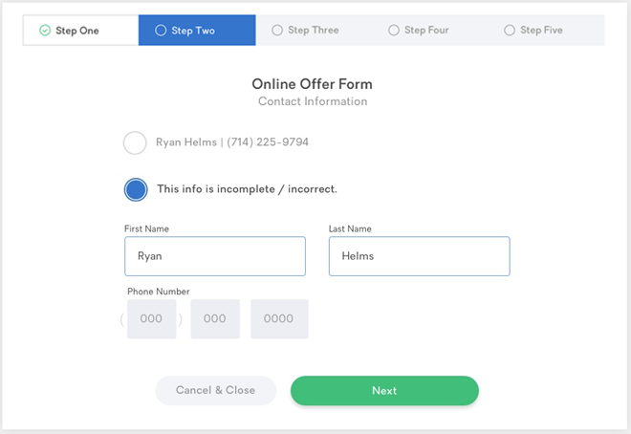

* If contact information is to be completed or corrected:
  + Display data entry form with editable fields for name and phone number.
  + Pre-fill the first and last name fields with the name from the user’s profile.
  + Pre-fill the phone number field if a value exists in the user’s profile.
* All fields are required.
* Disable the Next button until after the user completes the form fields or selects the option to use existing contact information.

## Online Offer Step 3 - Agent Information

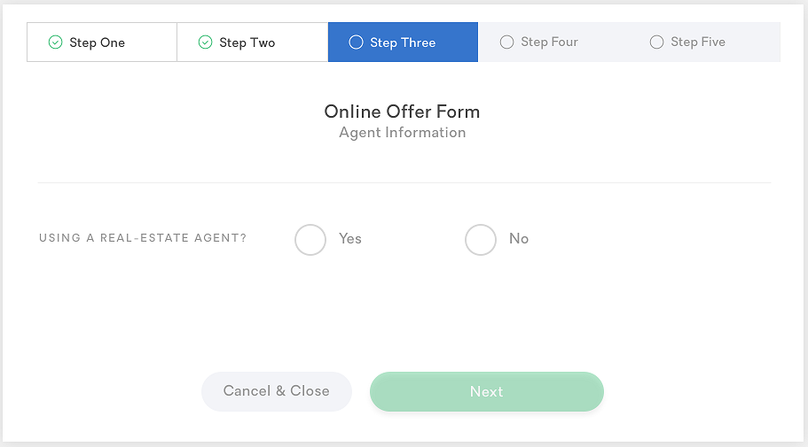

* Update the progress tracker; highlight Step 3.
* Ask the user if s/he is working with a real estate agent and display Yes and No options.
* Do not pre-select either option (require the user to choose).
* Enable the Next button only after an option is chosen.
* If the user answers “Yes”, see screen on the next page.

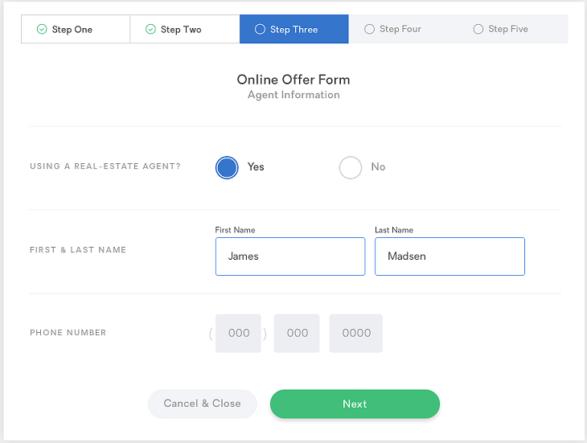

* If the user selects “Yes”, using a real estate agent, display data entry form with editable fields for the agent’s first and last name and phone number.
* All fields are required.
* Remove these fields if the user selects “No”.

## Online Offer Step 4 - Terms & Conditions

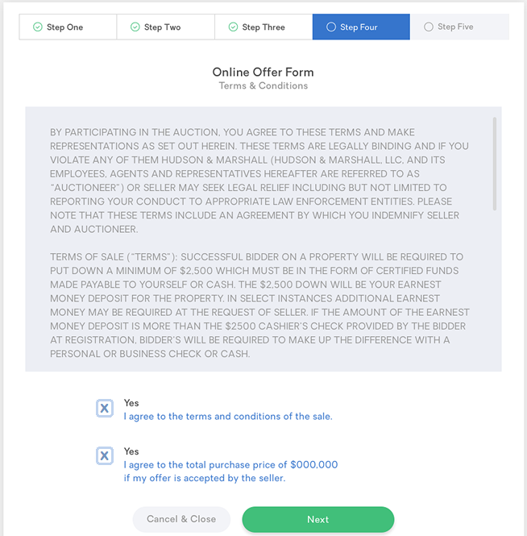

* Update the progress tracker; highlight Step 4.
* Display the Terms & Conditions in a scrollable region.
* Display checkbox options to accept the terms and to agree to the purchase price; neither option should be pre-selected (require the user to check both).
* Enable the Next button only after the user selects both options.

## Online Offer Step 5 - Thank you!

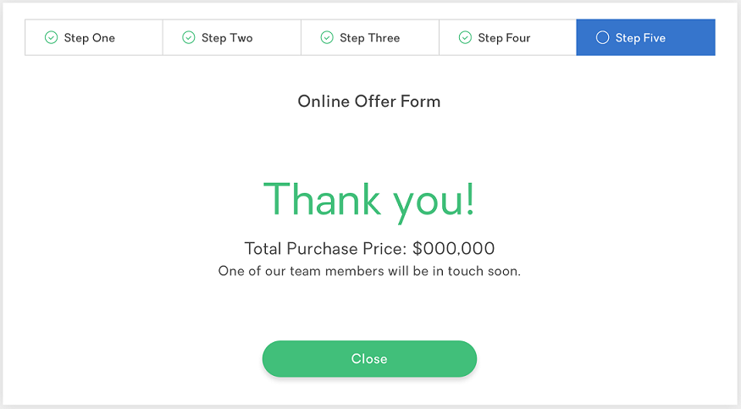

* Update the progress tracker; highlight Step 5.
* Prompt the user to close the form and return to the auction site/app.

## Online Offer Mobile App

The Online Offer process on the mobile app should be the same multi-step process used on the website.

|  |  |
| --- | --- |
|  |  |

|  |  |
| --- | --- |
|  |  |

|  |  |
| --- | --- |
|  |  |